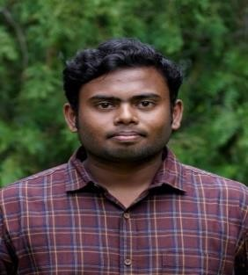ARUNKUMAR T



# MCA, COMPUTER APPLICATIONS

 7094904244

 [arunkumar. 22 mca@ kct. ac. in](mailto:arunkumar.22mca@kct.ac.in)

<https://www.linkedin.com/in/arunkumar-thangam-9baa521b5/>



# CAREER PROFILE

Candidate interested in the field of analytics & developer with good communication and presentation skills who loves to take up new responsibilities and open to constructive criticism looking to secure a job at a good organization to make the most of skills and to get exposure.

# EDUCATION

**Master, Computer Application**

Kumaraguru College of Technology Affiliated to Anna University Coimbatore, Tamil Nadu

# Bachelor, Computer Application

Ayya Nadar Janaki Ammal college Sivakasi, Virdhunagar, Tamil Nadu.

# Class 12

G.S HINDU HR SEC SCHOOL SRIVIILIPUTTUR STATE BOARD,

VIRDHUNAGAR, Tamil Nadu.

**Class 10**

G.S HINDU HR SEC SCHOOL SRIVIILIPUTTUR STATE BOARD,

VIRDHUNAGAR, Tamil Nadu.

Graduation: May 2025

CGPA:8.3

Graduation : May 2023

CGPA:7.4

2019

65.66 %

2017

91 %



# SKILLS

## SOFT SKILLS

* Good communicator
* Quick learner
* Problem solver
* Results driven
* Leadership skills

## TECHNICAL SKILLS

* C and C++
* Java (Basics)
* SQL
* HTML, CSS
* Python (basics)

## 



# CERTIFICATION AND PROJECTS

* **MCA MINI PROJECT IN (WEB APPLICATION)** – FEES SYNC MINI
* **MCA IOT PROJECT –** SMART DUSTBIN AND MOBILE APPLICATION FOR TRACKING
* **MCA IOT PROJECT –** SMART STREET LIGHT MANAGEMENT SYSTEM AND MOBILE APPLICATION
* Currently Doing a Course on “THE DATA SCIENCE COURSE: COMPLETE DATA SCIENCE” by UDEMY.
* Currently Doing a Course on “HTML, CSS, and Java script for Web Developers” by Coursera.
* Currently Doing a Course on “Foundation: Data, Data, Everywhere ” by Coursera.



# PROFESSIONAL MEMBERSHIP

* **ALUMNI COORDINATOR** – MCA, Kumaraguru College of Technology



# PERSONAL DETAILS

Father’s Name: THANGAM L Occupation: POLICE

Mother’s Name: SENTHAMILSELVI Occupation: HOME MAKER

Birthday: 22.06.2001 Nationality: Indian Gender: MALE

Address:13/2 EAST COLONY STREET MAMSAPURAM.

**Declaration**

I, ARUNKUMAR T hereby declare that the information contained herein is true and correct to the best of my knowledge and belief.

ARUNKUMAR T